BTS Travel Award report (TATT 2018, China) – Dr Helen Prior, National Centre for the Replacement, Refinement & Reduction of Animals in Research (NC3Rs).

In October last year I was fortunate to be invited, along with my colleague Dr Fiona Sewell, to speak at the 4th International Conference on Toxicity Testing Alternatives & Translational Toxicology (TATT) joint conference with the 2nd Asian Congress on Alternatives, in Guangzhou, China. A BTS travel award contributed towards my flight, whilst our hotel accommodation and meeting registrations were kindly supported by the Chinese Society of Toxicology. The work of the NC3Rs is increasingly international and this trip was part of a wider commitment to collaborate with Chinese scientists and regulators in promoting scientific and technological innovations in the replacement, reduction and refinement (3Rs) of animals in research.
The conference aimed to discuss and promote worldwide research developments and application of toxicity testing alternatives and translational toxicology in the 21st century, and enhance communication between international academic researchers, industry and regulatory agencies. Held in a spacious conference centre on the edge of the southern city of Guangzhou, it brought together more than 500 delegates from 10 different countries for two days of presentations, posters and vendor exhibition. We were treated as honoured guests, being met and escorted from the airport, with reserved seats at the front and beautiful speciality Cantonese banquets in the evenings. Day one was dedicated to plenary lectures, with talks highlighting approaches towards the acceptance of alternative methods and examples of new in vitro models within the cosmetics, chemical and pharmaceutical industries. The stage and screen were vast, with English translation on the left and Chinese on the right (see photo of Fiona below) and simultaneous translation via headsets. Day two saw six parallel sessions, including ‘3Rs and development of alternatives’, in which I spoke about applying the 3Rs within non-human primate (NHP) use for monoclonal antibody development. Other sessions included one organised by Unilever’s Safety and Environmental Assurance Centre (SEAC, UK) on the ‘Use of new approach methods (NAM) in next generation risk assessments (NGRA)’ for cosmetics and consumer products.

There can be no doubt that scientific advances and technologies are progressing rapidly within China, supported by funding for academia and a willingness from regulators to consider alternatives to animal methods. The need to move away from in vivo work was recognised in the majority of presentations as a primarily ethical consideration, but also acknowledged that in vitro and in silico methods can improve predictivity and timelines to market. This was the first trip to China for both of us and we were impressed at the friendliness, cleanliness and modernity of the city. We look forward to returning and to interact more with our new contacts in the future.

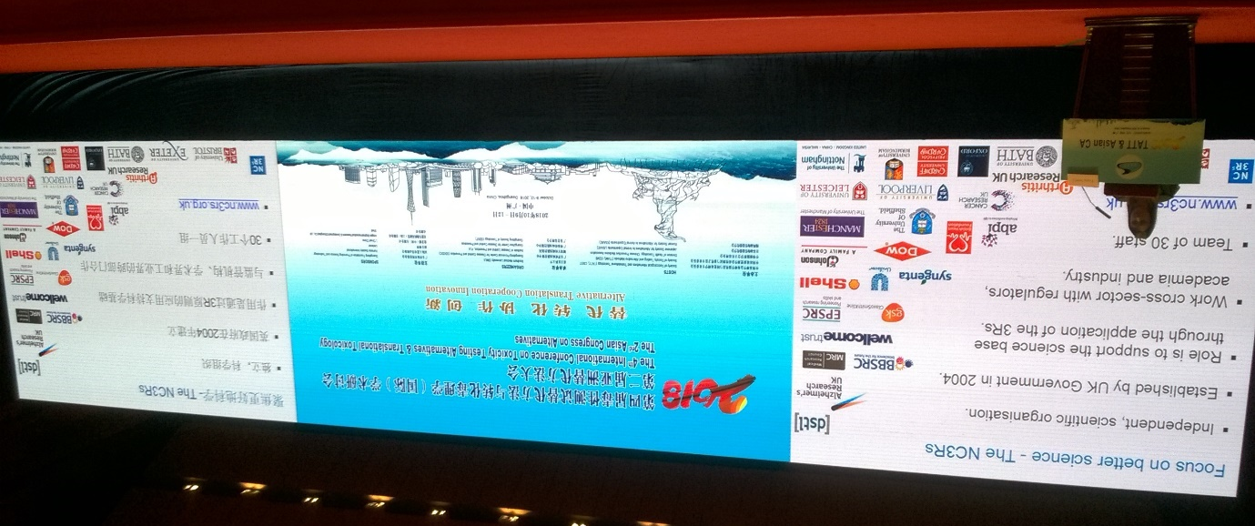
Dr Fiona Sewell giving her plenary lecture ‘Evidence-building to influence changes in regulations and guidelines: pioneering better science by applying the 3Rs’.

The Canton Tower in the urban downtown Pearl River district of Guangzhou.
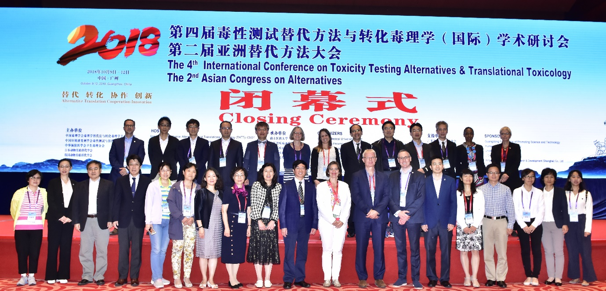
The speakers and special guests (Helen and Fiona, centre back row).

